Article 14 — The Signal Layer
Michal Doroszewski

The Airport Intercom
You’re standing in a busy airport terminal. Flights are boarding, people are moving, announcements echo overhead. You hear the intercom crackle: “Flight 227 now boarding at Gate—” and then the audio cuts out. A burst of static replaces the gate number. The message restarts, then cuts again. The crowd looks around, unsure whether to move or stay.
A second announcement begins: “Final call for—” and the rest dissolves into noise. The screens flicker. The gate assignments update, then revert, then update again. A family starts walking toward Gate C12, then stops, then turns around. A pilot steps out of a jet bridge, confused, checking a tablet that shows three different gate numbers for the same flight.
The intercom tries again: “Attention passengers—signal lost. Please stand by.”
The problem isn’t the flights. The problem isn’t the passengers. The problem isn’t the staff. The problem is the signal. The system cannot deliver a complete message from one end of the terminal to the other. Every announcement becomes a guess. Every instruction becomes a negotiation. Every decision becomes a gamble.
That is the Signal Problem — not the “weak Wi‑Fi” kind, but the architectural kind. The kind that appears when cloud systems cannot reliably transmit the identity, posture, location, and risk signals required to evaluate trust. The kind that turns a functioning system into a guessing machine.
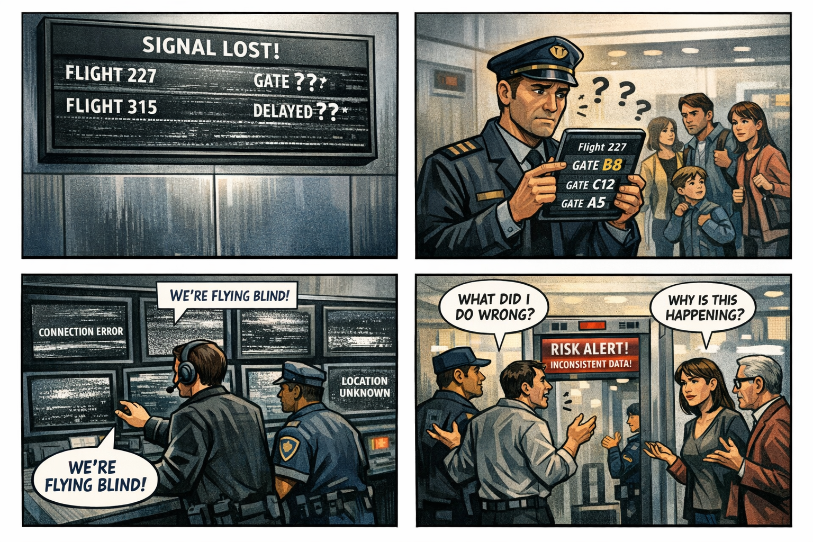

Signals Are the Fourth Layer of Modernization
Visibility shows what is happening. Continuity stabilizes identity across transitions. Control determines what the system is allowed to do. But signals carry the truth that makes all of it possible.
Modern identity platforms depend on a constant stream of signals — device posture, token freshness, network location, risk evaluation, compliance state, session context. These signals must arrive intact, on time, and in the right order. When they don’t, the system does not fail. It hesitates. It contradicts itself. It misclassifies. It denies. It resets.
A system without reliable signals is not insecure. It is incoherent.

Why GCC‑Moderate Breaks Signals
The FedRAMP Moderate boundary was built for static trust, not dynamic signal flow. It filters, delays, or distorts the very signals modern identity depends on. Device posture arrives late. Location arrives mislabeled. Risk arrives incomplete. Token refresh arrives out of order. Policy evaluation receives fragments instead of facts.
The system is not rejecting the user. It is rejecting the uncertainty.
Signals that should arrive in milliseconds arrive in seconds — or not at all. Signals that should be consistent vary by region, by path, by time of day. Signals that should be authoritative become contradictory. The architecture does not break the signals. It breaks the trust in the signals.

Headquarters and Field Offices Experience Signals Differently
Headquarters sits close to the identity fabric. Signals travel short distances. Timing is predictable. Evaluation is consistent. The system sees the truth clearly.
Field offices sit behind WAN optimizers, inspection layers, and region drift. Signals take longer paths. Timing becomes unstable. Evaluation becomes inconsistent. The system sees fragments of the truth and fills the gaps with assumptions.
The same user, same device, same request — different signals. The architecture creates two realities, and the system enforces both.

Why Signal Failures Are Misdiagnosed
When signals collapse, every team sees a different symptom.
Identity sees token failures. Security sees posture gaps. Network sees latency. Operations sees region drift. Users see random denials.
Everyone is correct. Everyone is wrong.
The failure is architectural. The system cannot evaluate trust because the signals required to evaluate trust never arrive intact. A system cannot enforce policy with partial truth. A system cannot maintain trust with delayed truth. A system cannot modernize with distorted truth.

Modernization Stalls Without Signals
Without reliable signals:
device trust oscillates
location misclassifies
risk fluctuates
sessions reset
policies contradict
authentication loops
users lose confidence
teams chase ghosts
This is not a configuration problem. It is architectural signal loss.

The Root of the Signal Problem
The signal problem is not caused by misconfigured policies, incorrect groups, user error, or device drift. It is caused by an architecture that cannot reliably transmit the truth required for modern identity.
The boundary filters the truth. The WAN delays the truth. The inspection layers distort the truth. The region model mislabels the truth. The identity platform receives partial truth.
A system cannot function on partial truth. A system cannot modernize on delayed truth. A system cannot trust what it cannot hear.

The Only Way Forward
Signal integrity must be restored.
The boundary must allow identity‑critical signals. Timing must be preserved end‑to‑end. Region awareness must be accurate. Device posture must be current. Risk evaluation must be complete. Token refresh must be stable. Policy evaluation must receive the full truth.
Only then can trust be consistent. Only then can decisions be predictable. Only then can modernization move forward without noise.

Disclaimer
Not all agencies will experience the issues described in this article. These behaviors occur primarily in architectures where cloud identity, Conditional Access, and real‑time policy evaluation depend on signals that traverse GCC‑Moderate boundaries, WAN inspection layers, or region‑variable paths. Agencies that rely on direct Active Directory authentication, maintain on‑premises identity controllers, or operate with short, stable network paths may see different outcomes. These observations reflect common patterns in GCC‑Moderate cloud environments, not universal conditions.

About the Author
Michal Doroszewski is a technology strategist focused on cloud architecture, identity platforms, and federal modernization. He writes about the structural and architectural forces that shape government IT, translating complex technical constraints into clear, accessible narratives for leaders and practitioners.

